**Hibernate with JPA**

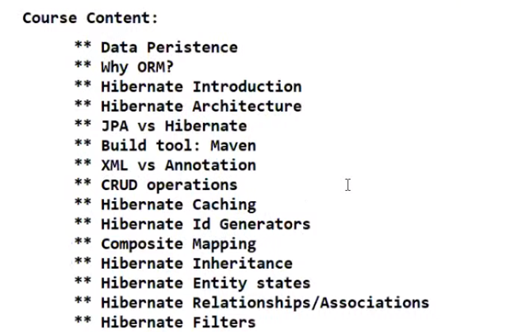

**\*\* Hibernate Transactions**

**\*\* Hibernate Locking**

Data Persistence:

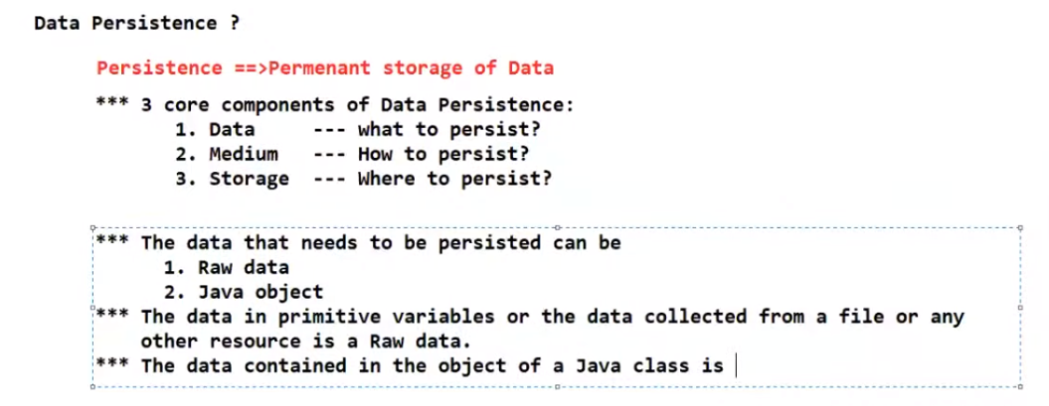

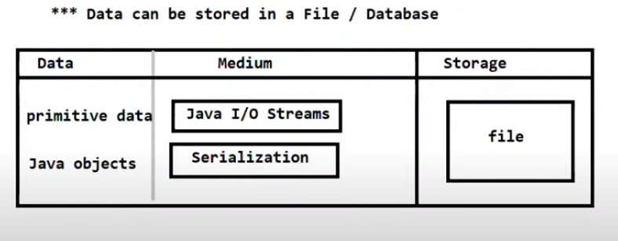

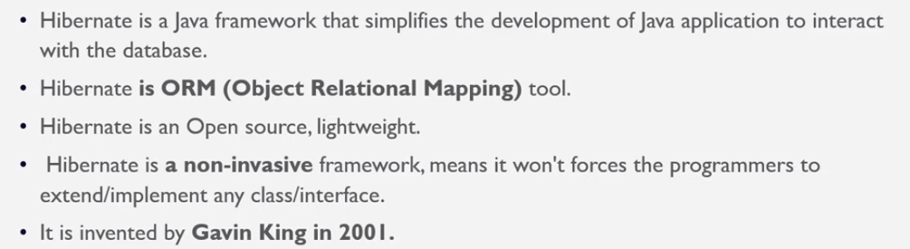

Sample Application:

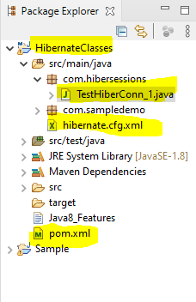

pom.xml:

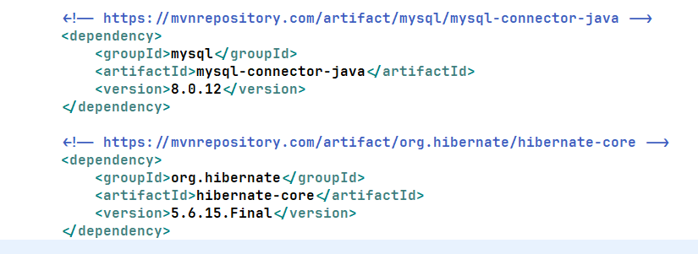

hibernate.cfg.xml

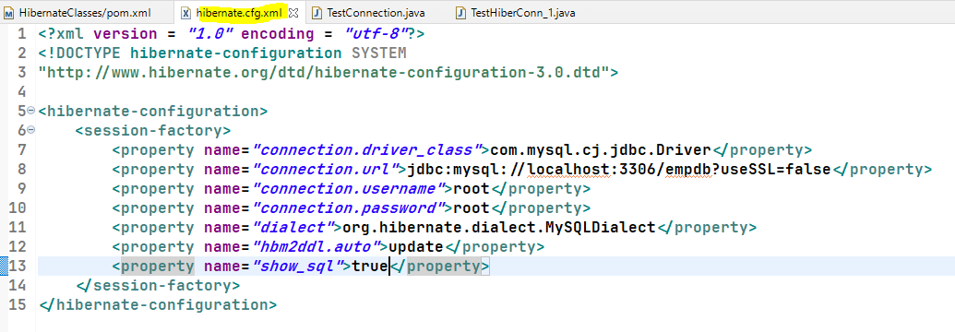

Main Class:

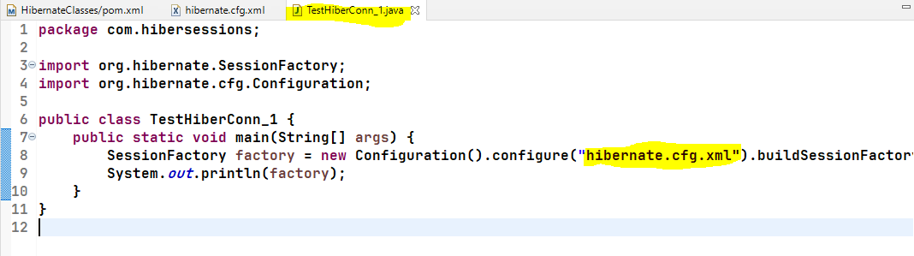

Sample output:

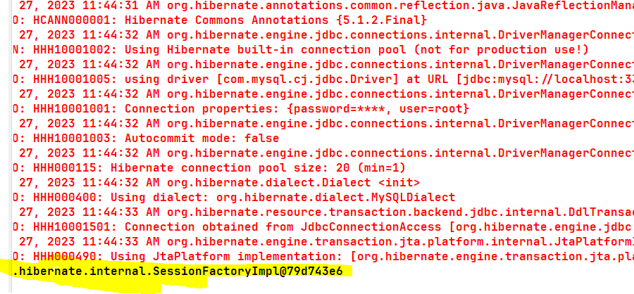

<?xml version = *"1.0"* encoding = *"utf-8"*?>

<!DOCTYPE hibernate-configuration SYSTEM

"http://www.hibernate.org/dtd/hibernate-configuration-3.0.dtd">

<hibernate-configuration>

<session-factory>

<property name=*"connection.driver_class"*>com.mysql.cj.jdbc.Driver</property>

<property name=*"connection.url"*>jdbc:mysql://localhost:3306/empdb?useSSL=false</property>

<property name=*"connection.username"*>root</property>

<property name=*"connection.password"*>root</property>

<property name=*"dialect"*>org.hibernate.dialect.MySQLDialect</property>

<property name=*"hbm2ddl.auto"*>update</property>

<property name=*"show_sql"*>true</property>

</session-factory>

</hibernate-configuration>